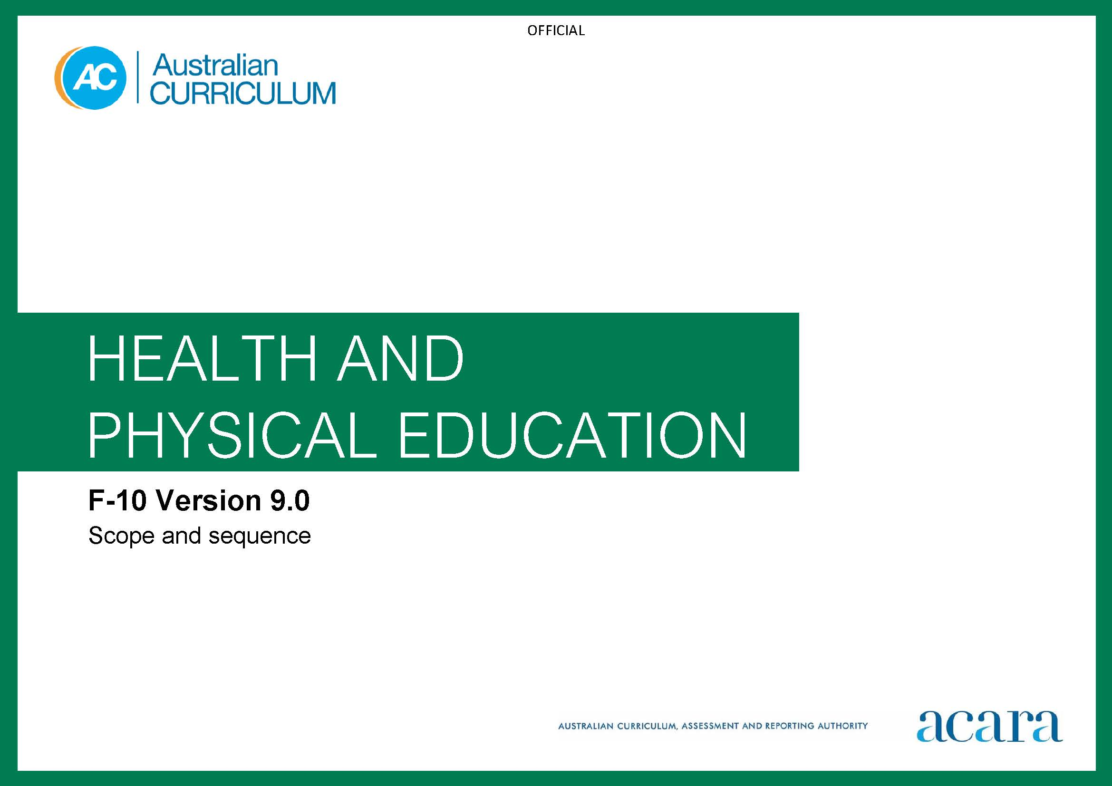

Copyright and Terms of Use Statement
© Australian Curriculum, Assessment and Reporting Authority 2022
The material published in this work is subject to copyright pursuant to the Copyright Act 1968 (Cth) and is owned by the Australian Curriculum, Assessment and Reporting Authority (ACARA) (except to the extent that copyright is held by another party, as indicated).
The viewing, downloading, displaying, printing, reproducing (such as by making photocopies) and distributing of these materials is permitted only to the extent permitted by, and is subject to the conditions imposed by, the terms and conditions of using the ACARA website (see, especially, clauses 2, 3 and 4 of those terms and conditions). The terms and conditions can be viewed at https://www.acara.edu.au/contact-us/copyright

Foundation | Years 1–2
Achievement standard
By the end of Foundation, students describe similarities and differences between themselves and others, and different emotions people experience. They demonstrate personal and social skills to interact respectfully with others. They identify and demonstrate protective behaviours and help-seeking strategies to keep themselves safe. Students identify how health information can be used in their lives. Students apply fundamental movement skills to manipulate objects and space in a range of movement situations. Students identify the benefits of being physically active and how rules make play fair and inclusive. | By the end of Year 2, students explain how personal qualities contribute to identities. They describe how emotional responses affect their own and others' feelings. They demonstrate skills and describe strategies required to develop respectful relationships. Students apply protective behaviours and help-seeking strategies to keep themselves and others safe. They explain why health information is important for making choices. Students apply fundamental movement skills in different movement situations and explain how they move with objects and in space effectively. They describe factors that make physical activity beneficial. Students develop and apply rules while collaborating with others in a range of movement contexts.

Content descriptions
Strand: Personal, social and community health
Sub-strand: Identities and change
investigate who they are and the people in their world  AC9HPFP01 | describe their personal qualities and those of others, and explain how they contribute to developing identities  AC9HP2P01
Sub-strand: Interacting with others
practise personal and social skills to interact respectfully with others  AC9HPFP02 | identify and explore skills and strategies to develop respectful relationships  AC9HP2P02
express and describe emotions they experience  AC9HPFP03 | identify how different situations influence emotional responses  AC9HP2P03
explore how to seek, give or deny permission respectfully when sharing possessions or personal space  AC9HPFP04 | practise strategies they can use when they need to seek, give or deny permission respectfully  AC9HP2P04
Sub-strand: Making healthy and safe choices
demonstrate protective behaviours, name body parts and rehearse help-seeking strategies that help keep them safe  AC9HPFP05 | identify and demonstrate protective behaviours and help-seeking strategies they can use to help them and others stay safe  AC9HP2P05
identify health symbols, messages and strategies in their community that support their health and safety  AC9HPFP06 | investigate a range of health messages and practices in their community and discuss their purposes  AC9HP2P06

Strand: Movement and physical activity
Sub-strand: Moving our bodies
practise fundamental movement skills in minor game and play situations  AC9HPFM01 | practise fundamental movement skills and apply them in a variety of movement situations  AC9HP2M01
experiment with different ways of moving their body safely and manipulating objects and space  AC9HPFM02 | investigate different ways of moving their body, and manipulating objects and space, and draw conclusions about their effectiveness  AC9HP2M02
Sub-strand: Making active choices
participate in a range of activities in natural and outdoor settings and explore the benefits of being physically active  AC9HPFM03 | participate in a range of physical activities in natural and outdoor settings, and investigate factors and settings that make physical activity enjoyable  AC9HP2M03
Sub-strand: Learning through movement
follow rules to promote fair play in a range of physical activities  AC9HPFM04 | co-construct and apply rules to promote fair play in a range of physical activities  AC9HP2M04
apply strategies to work collaboratively when participating in physical activities
AC9HP2M05

Years 3–4 |  | Years 5–6
Achievement standard
By the end of Year 4, students identify influences that strengthen identities and describe strategies to manage emotions, changes and transitions. They apply skills and strategies to interact respectfully with others. They describe the influences that inclusion and stereotypes have on choices and actions. Students describe and apply protective behaviours and help-seeking strategies to keep themselves and others safe online and offline. They interpret health information to apply strategies to enhance their own and others’ health, safety, relationships and wellbeing. Students apply fundamental movement skills and demonstrate movement concepts across a range of situations. They adapt movement strategies to enhance movement outcomes. Students examine factors that influence participation and propose strategies to incorporate regular physical activity into their own and others’ lives. They demonstrate fair play and inclusion through a range of roles in movement contexts. | By the end of Year 6, students explain how different factors influence identities. They propose strategies to manage emotions, developmental changes and transitions. They propose strategies to demonstrate respect, empathy and inclusion. They explain how stereotypes influence roles and responsibilities. Students explain how communication skills, protective behaviours and help-seeking strategies keep themselves and others safe online and offline. They analyse health information to refine strategies to enhance their own and others’ health, safety, relationships and wellbeing. Students refine and modify movement skills and apply movement concepts across a range of situations. They transfer movement strategies between situations and evaluate the impact on movement outcomes. Students propose strategies to promote physical activity participation that enhance health, fitness and wellbeing. They describe contributions they can make as a group and team member to support fair play and inclusion across a range of movement contexts.

Content descriptions
Strand: Personal, social and community health
Sub-strand: Identities and change
investigate how success, challenge, setbacks and failure strengthen resilience and identities in a range of contexts  AC9HP4P01 | explain how identities can be influenced by people and places, and how we can create positive self-identities  AC9HP6P01
plan, rehearse and reflect on strategies to cope with the different changes and transitions they experience, such as the changes associated with puberty  AC9HP4P02 | investigate resources and strategies to manage changes and transitions, including changes associated with puberty  AC9HP6P02
describe how choices and actions can be influenced by stereotypes  AC9HP4P03 | investigate how the portrayal of societal roles and responsibilities can be influenced by gender stereotypes  AC9HP6P03
Sub-strand: Interacting with others
select, use and refine personal and social skills to establish, manage and strengthen relationships  AC9HP4P04 | describe and demonstrate how respect and empathy can be expressed to positively influence relationships  AC9HP6P04
describe how valuing diversity influences wellbeing and identify actions that promote inclusion in their communities  AC9HP4P05 | describe and implement strategies to value diversity in their communities  AC9HP6P05
explain how and why emotional responses can vary and practise strategies to manage their emotions  AC9HP4P06 | apply strategies to manage emotions and analyse how emotional responses influence interactions  AC9HP6P06
rehearse and refine strategies for seeking, giving and denying permission respectfully and describe situations when permission is required  AC9HP4P07 | describe strategies for seeking, giving or denying consent and rehearse how to communicate their intentions effectively and respectfully  AC9HP6P07
Sub-strand: Making healthy and safe choices
describe and apply protective behaviours and help-seeking strategies in a range of online and offline situations  AC9HP4P08 | analyse and rehearse protective behaviours and help-seeking strategies that can be used in a range of online and offline situations  AC9HP6P08
interpret the nature and intention of health information and messages, and reflect on how they influence personal decisions and behaviours  AC9HP4P09 | investigate different sources and types of health information and how these apply to their own and others’ health choices  AC9HP6P09
investigate and apply behaviours that contribute to their own and others’ health, safety, relationships and wellbeing  AC9HP4P10 | analyse how behaviours influence the health, safety, relationships and wellbeing of individuals and communities  AC9HP6P10

Strand: Movement and physical activity
Sub-strand: Moving our bodies
refine and apply fundamental movement skills in new movement situations  AC9HP4M01 | adapt and modify movement skills across a variety of situations  AC9HP6M01
apply and adapt movement strategies to achieve movement outcomes  AC9HP4M02 | transfer familiar movement strategies to different movement situations  AC9HP6M02
demonstrate how movement concepts related to effort, space, time, objects and people can be applied when performing movement sequences  AC9HP4M03 | investigate how different movement concepts related to effort, space, time, objects and people can be applied to improve movement outcomes  AC9HP6M03
Sub-strand: Making active choices
participate in physical activities to explore how their body feels and describe how regular physical activity helps the body stay healthy and well  AC9HP4M04 | participate in physical activities to investigate the body’s reaction to different levels of intensity  AC9HP6M04
participate in physical activities in natural and outdoor settings to examine factors that can influence their own and others’ participation  AC9HP4M05 | participate in physical activities that enhance health and wellbeing in natural and outdoor settings, and analyse the steps and resources needed to promote participation  AC9HP6M05
explore recommendations about physical activity and sedentary behaviours, and discuss strategies to achieve the recommendations  AC9HP4M06 | propose and explain strategies to increase physical activity and reduce sedentary behaviour levels in their lives  AC9HP6M06

Sub-strand: Learning through movement
apply creative thinking when designing movement sequences and solving movement problems  AC9HP4M07 | predict and test the effectiveness of applying different skills and strategies in a range of movement situations  AC9HP6M07
apply rules and scoring systems to promote fair play when participating or designing physical activities  AC9HP4M08 | devise and test alternative rules and game modifications to support fair play and inclusive participation  AC9HP6M08
perform a range of roles in respectful ways to achieve successful outcomes in group or team movement activities  AC9HP4M09 | participate positively in groups and teams by contributing to group activities, encouraging others and negotiating roles and responsibilities  AC9HP6M09

Years 7–8 |  | Years 9–10
Achievement standard
By the end of Year 8, students analyse factors that influence identities, emotions and responses to change, and describe strategies to respond to these influences. They analyse how stereotypes, respect, empathy and valuing diversity influence relationships. Students analyse the effectiveness of assertive communication strategies, protective behaviours and help-seeking strategies applied online and offline. They analyse health information and messages to propose strategies that enhance their own and others’ health, safety, relationships and wellbeing. Students apply and transfer movement skills and movement concepts across a range of situations. They implement and evaluate the effectiveness of movement strategies on movement outcomes. Students propose and evaluate strategies designed to achieve personal health, fitness and wellbeing outcomes. They select, use and refine strategies to support inclusion, fair play and collaboration across a range of movement contexts. | By the end of Year 10, students propose and evaluate personal strategies to manage their identities, emotions and responses to change. They evaluate how attitudes and beliefs about equality, respect, diversity and inclusion influence the nature and quality of relationships. Students propose and justify strategies to manage online and offline situations where their own or others’ health, safety, relationships or wellbeing may be at risk. They synthesise health information from credible sources to propose and justify strategies to enhance their own and others’ health, safety, relationships and wellbeing. Students evaluate and refine their own and others’ movement skills and performances, and apply movement concepts in challenging or unfamiliar situations. They adapt and transfer movement strategies to unfamiliar situations to achieve successful outcomes. Students propose and evaluate community-based physical activity interventions designed to improve the health, fitness and wellbeing of themselves and others. They apply and evaluate leadership approaches, collaboration strategies and ethical behaviours across a range of movement contexts.

Content descriptions
Strand: Personal, social and community health
Sub-strand: Identities and change
analyse and reflect on the influence of values and beliefs on the development of identities  AC9HP8P01 | analyse factors that shape identities and evaluate how individuals influence the identities of others  AC9HP10P01
analyse the impact of changes and transitions, and devise strategies to support themselves and others through these changes  AC9HP8P02 | refine, evaluate and adapt strategies for managing changes and transitions  AC9HP10P02
examine how roles, decision-making, and levels of power, coercion and control within relationships can be influenced by gender stereotypes  AC9HP8P03 | investigate how gender equality and challenging assumptions about gender can prevent violence and abuse in relationships  AC9HP10P03
Sub-strand: Interacting with others
examine the roles of respect, empathy, power and coercion in developing respectful relationships  AC9HP8P04 | evaluate the influence of respect, empathy, power and coercion on establishing and maintaining respectful relationships  AC9HP10P04
investigate strategies that influence how communities value diversity and propose actions they can take to promote inclusion in their communities  AC9HP8P05 | propose strategies and actions individuals and groups can implement to challenge biases, stereotypes, prejudices and discrimination, and promote inclusion in their communities  AC9HP10P05
analyse factors that influence emotional responses and devise strategies to self-manage emotions  AC9HP8P06 | evaluate emotional responses in different situations to refine strategies for managing emotions  AC9HP10P06
explain and apply skills and strategies to communicate assertively and respectfully when seeking, giving or denying consent  AC9HP8P07 | examine how strategies, such as communicating choices, seeking, giving and denying consent, and expressing opinions and needs can support the development of respectful relationships, including sexual relationships  AC9HP10P07
Sub-strand: Making healthy and safe choices
refine protective behaviours and evaluate community resources to seek help for themselves and others  AC9HP8P08 | plan, rehearse and evaluate strategies for managing situations where their own or others’ health, safety or wellbeing may be at risk  AC9HP10P08
investigate how media and influential people impact attitudes, beliefs, decisions and behaviours in relation to health, safety, relationships and wellbeing  AC9HP8P09 | critique health information, services and media messaging about relationships, lifestyle choices, health decisions and behaviours to evaluate their influence on individual attitudes and actions  AC9HP10P09
plan and implement strategies, using health resources, to enhance their own and others’ health, safety, relationships and wellbeing  AC9HP8P10 | plan, justify and critique strategies to enhance their own and others’ health, safety, relationships and wellbeing  AC9HP10P10

Strand: Movement and physical activity
Sub-strand: Moving our bodies
analyse, refine and transfer movement skills in a variety of movement situations  AC9HP8M01 | analyse, adapt and refine their own and others’ movement skills in a range of challenging movement situations to enhance performance  AC9HP10M01
design and demonstrate how movement strategies can be manipulated to improve movement outcomes  AC9HP8M02 | create and refine movement strategies to achieve successful outcomes across a range of challenging movement situations  AC9HP10M02
demonstrate and explain how movement concepts related to effort, space, time, objects and people can be manipulated to improve movement outcomes  AC9HP8M03 | apply movement concepts in new or challenging movement situations and analyse the impact each concept has on movement outcomes  AC9HP10M03
Sub-strand: Making active choices
participate in physical activities designed to improve fitness and wellbeing to investigate the impact of regular participation on health, fitness and wellbeing  AC9HP8M04 | participate in physical activities designed to enhance health, wellbeing and fitness, and design, apply and evaluate strategies for incorporating these activities into their lives  AC9HP10M04
participate in physical activities that utilise community spaces and outdoor settings, and evaluate strategies to support increased use of these spaces  AC9HP8M05 | participate in physical activities that promote health and social outcomes to design and evaluate participation strategies for themselves and others  AC9HP10M05
design and justify strategies to increase physical activity levels to achieve health and wellbeing outcomes  AC9HP8M06 | design, implement and evaluate personalised plans for improving or maintaining their own or others’ physical activity levels to achieve fitness, health and wellbeing outcomes  AC9HP10M06
Sub-strand: Learning through movement
propose and evaluate movement strategies and skills that would be most effective in different movement situations  AC9HP8M07 | transfer and adapt skills and strategies from previous experiences to create successful outcomes in unfamiliar movement situations  AC9HP10M07
investigate modifications to equipment, rules and scoring systems that support fair play and inclusive participation  AC9HP8M08 | demonstrate fair play and reflect on how ethical behaviour can influence physical activity outcomes for individuals and groups  AC9HP10M08
practise and apply leadership, collaboration and group decision-making processes when participating in a range of physical activities  AC9HP8M09 | devise, implement and refine strategies for decision-making when working in groups or teams that demonstrate leadership and collaboration skills  AC9HP10M09

